Sumer Case Study
Features of Civilization / City Planning

The first settled civilizations occurred in Mesopotamia by people called Sumerians around 3200 BCE. Building this civilization involved planning and detailed construction. These people were concerned with family, work, religion and art, but they also had to protect themselves from outsiders, layout a logical road and irrigation system and devise systems of government. By recreating an ancient city, you will gain a better understanding of what it took to organize a civilization.

Directions
- Use the information in your folder to design a city like that of the ancient Sumerians.

- This may be a map, a city overview, an artistic collage or something different.

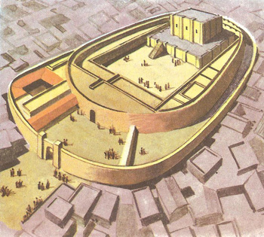
- Your Sumerian city should very clearly represent what you learned from the information in the folder and about the features of civilization.

- Consider the features of civilization:
Social classes/structure
Organized Government
Complex Religion
The Arts and Architecture
Technology
Writing
Job specialization
Public Works

- Consider these aspects of civilization
Temples community farms public/government buildings
Irrigation systems single-family homes street layout
Brick-making factory public art center animal shelters
Multiple-family homes public meeting place walls around city for protection
Market food storage/granary

Remember your city should provide the basic needs of food and housing for the Sumerians and their families.

ONE THE LARGE SHEET OF PAPER, USE ALL OF THE INFORMATION FROM TODAY TO DESIGN A SUMERIAN CITY.
Directions:  For each of the aspects of Sumerian civilization:  - Read the info card in the folder at your table  - Record 2-4 facts  - Draw a quick sketch, symbol or diagram | Stable Food Supply:
Social Structure | Government
Religion | The Arts
Technology | Writing

