Name Hofmann
Block World History
Mirror, Mirror on the wall…
Who’s the ABSOLUTEST of them all?

Directions: Choose one of the absolute monarchs from below. Research this King or Queen and address each of the requirements below. You should compile this information into a brochure, booklet, small poster or another product of your choice. Use the back of this page to organize your research. THIS IS AN ASSESSMENT!

Standard: Research
- Phillip II of Spain  - Henry VIII of England  - Mary I of England  - Elizabeth I of England  - Henry IV of France  - Louis XIV of France | - Frederick the Great of Prussia  - Ivan the Terrible of Russia  - Peter the Great of Russia  - Catherine the Great of Russia  - Maria Theresa of Austria

Project Requirements:
- Picture
  - Accurate picture of monarch, printed or drawn

- Campaign Slogan
  - Campaign slogan for the monarch that reflects their goals, political viewpoints, political agenda, and/or accomplishment.
  - This should be creative and catchy. Make it memorable.

- Quote
  - One historical (actual) quote stated by the monarch that reflects their goals, political viewpoints, political agenda and/or accomplishments.

- Map
  - Find a map or in some way illustrate the land/country that the monarch ruled over. Label major cities, water ways, surrounding countries, etc.

- Fun Fact(s)
  - Something(s) about your monarch that was unique, odd, interesting, terrible, amazing…

- Absolutest of them All!
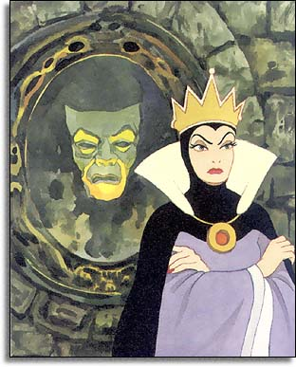
  - Why should your monarch receive the title of Most Absolute Monarch? Using evidence, argue why you monarch is the absolutest. Write an organized and thorough paragraph with a good claim, data and warrants.
The criteria you should use are how well your monarch:
    - Ruled/Lead/Controlled the nobility
    - Ruled/Lead/Controlled the peasantry
    - Ruled/Lead/Controlled the military
    - Controlled taxes and government spending
    - Dealt with foreign countries/monarchs
- Sources
  - Choose valid and reliable websites to conduct your research.
  - YOU MUST INCLUDE A PROPERLY FORMATTED WORKS CITED PAGE WITH AT LEAST THREE SOURCES. A good resource is easybib.com

Work Days: Thursday 1/8 and Monday 1/12 BOTH ARE PARTIAL WORK DAYS

Due Date: WEDNESDAY JANUARY 14
Campaign Slogan | Info for Map | Quote
Fun Facts | Why is your monarch Absolutest?? | Sources

