Proper Heading:

Intro to the Arab Spring
Part I: Background

Why would someone set themselves on fire? How can masses of young people spark revolution? How are current revolutionaries using Facebook, Twitter and Skype to change their world?

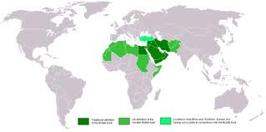
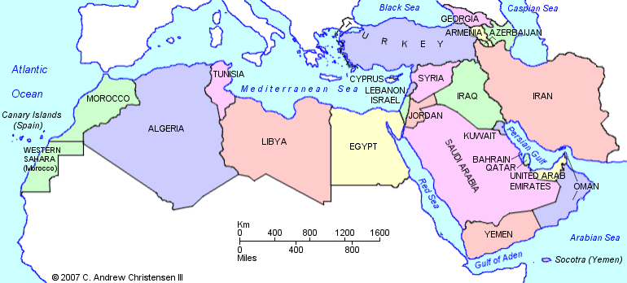
- Google: BBC Arab Uprisings. Click on Country by Country. Read about the situations in each country and focus on the four countries below. Identify the PILES of the revolutions.
Syria:
Tunisia:
Libya:
Egypt:

- What patterns are you noticing? What information is shocking or surprising? Why do you think these revolutionary ideas and actions started in one country and then, like a domino effect, spread across the region? What QUESTIONS do you have about the Arab Spring?

Intro to the Arab Spring
Part II: Arab Spring Timelines
Understanding the Arab Spring through pictures, dates, descriptions

- When you get to the library, log in and google “NPR Arab Spring timeline.” Click on the first website.
- Scroll through and read the headline and date of EACH caption.
- Next google “Arab Spring Timeline Guardian.” Explore this website. Pay attention to the key and what each of the colors mean. Read about events on this timeline. Notice the RED dots on the timeline.

Part III: Arab Spring Collage
Because of social media and the internet, images of revolution in the Middle East are everywhere. What can we learn from images, quotes, articles and videos?

After you have thoroughly explored this sites in parts I & II, choose one revolution: Tunisia, Egypt, Libya, Syria to focus on.

CREATE a computer generated collage. Open a Google document and title it “ARAB SPRING in (name of country you choose) . Save this document in your google docs or under YOUR NAME. Title it with a relevant title. On your collage include each of the following:
  - 5 images
  - 2-4 quotes
  - 1 chart or statistic
  - 3-5 recent facts/events that have occurred in there in the last month
Be neat and creative. Be ready to share/turn in.

This is due_____________

Complete and PRINT this for homework. Due NEXT CLASS.

Include your name/proper heading on the back or top.
