Classical and Operant Conditioning Examples:
Directions: Identify whether each example is CLASSICAL or OPERANT conditioning.
If it’s classical, identify the UR, US, CR, CS.
If it’s operant, identify the type of reinforcement or punishment.
Use the back of this page to help you…
_______________________________________________________________________________________________________
1. Every time someone flushes a toilet in the apartment building, the shower becomes very hot and causes the person to jump back. Over time, the person begins to jump back automatically after hearing the flush, before the water temperature changes.

2. Your father gives you a credit card at the end of your first year in college because you did so well. As a result, your grades continue to get better in your second year.

3. Your car has a red, flashing light that blinks annoyingly if you start the car without buckling the seat belt. You become less likely to start the car without buckling the seat belt.

4. You eat a new food and then get sick because of the flu. However, you develop a dislike for the food and feel nauseated whenever you smell it.

5. An individual receives frequent injections of drugs, which are administered in a small examination room at a clinic. The drug itself causes increased heart rate but after several trips to the clinic, simply being in a small room causes an increased heart rate.

6. A lion in a circus learns to stand up on a chair and jump through a hoop to receive a food treat.

7. A professor has a policy of exempting students from the final exam if they maintain perfect attendance during the quarter. His students’ attendance increases dramatically.

8. You check the coin return slot on a pay telephone and find a quarter. You find yourself checking other telephones over the next few days.

9. Your hands are cold so you put your gloves on. In the future, you are more likely to put gloves on when it’s cold.

10. John Watson conducted an experiment with a boy named Albert in which he paired a white rat with a loud, startling noise. Albert now becomes startled at the sight of the white rat.

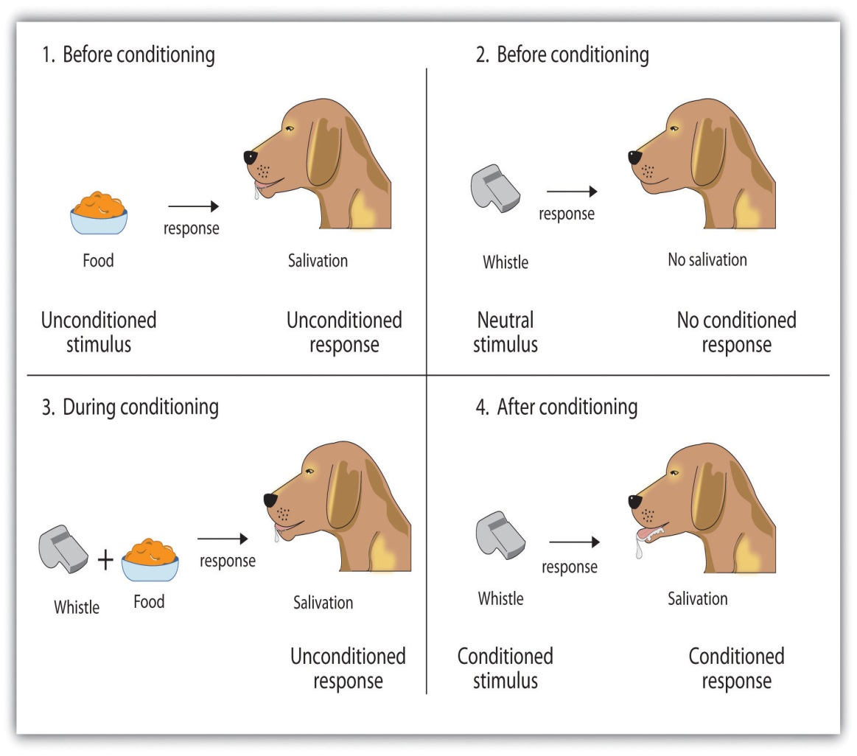
Classical Conditioning:
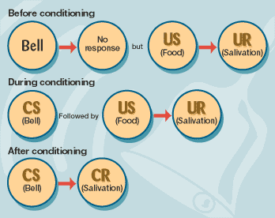

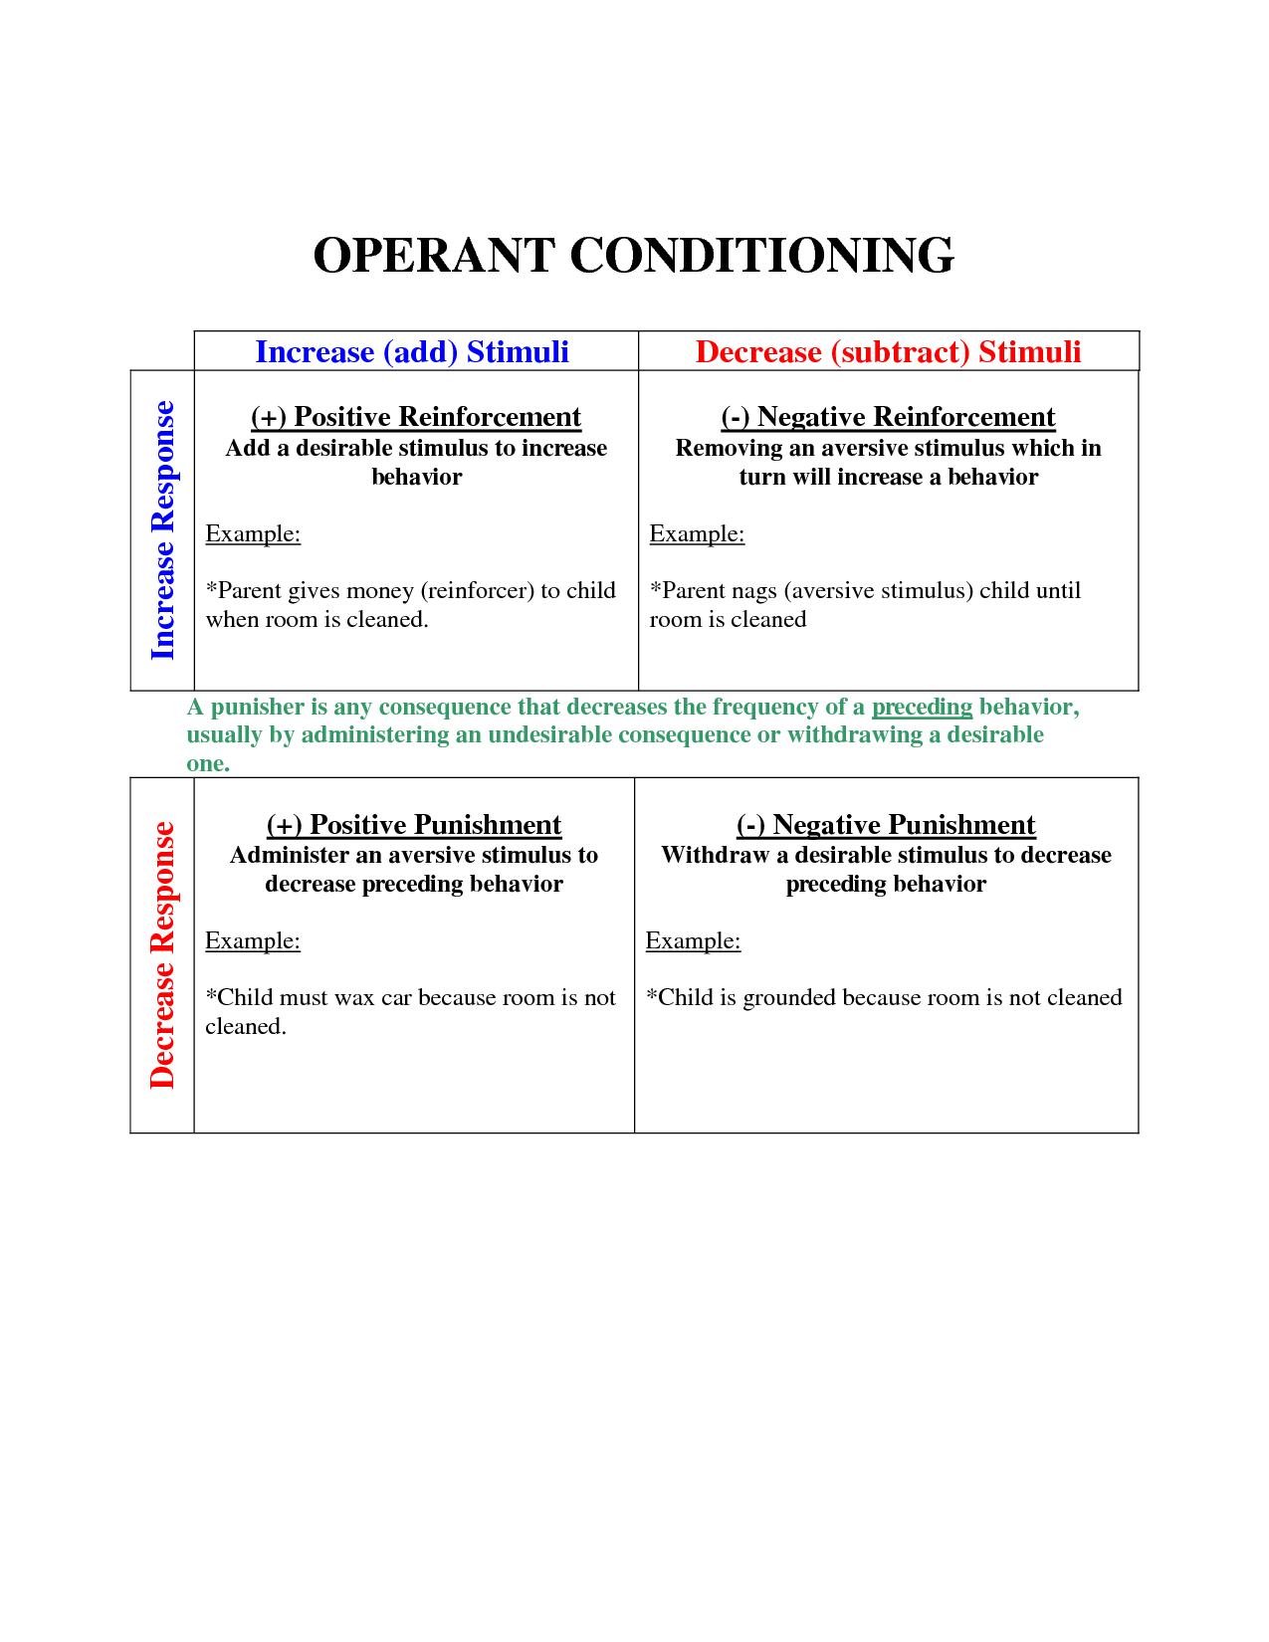

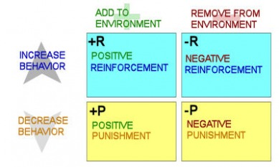

ANSWERS:
Example Number 1
Every time someone flushes a toilet in the apartment building, the shower becomes very hot and causes the person to jump back. Over time, the person begins to jump back automatically after hearing the flush, before the water temperature changes.
This example is classical conditioning because jumping away from hot water is an automatic response.
- The hot water is the US
- The jumping back is the UR
- The toilet flush is the CS
- The jumping back to the flush alone is the CR
Example Number 2
Your father gives you a credit card at the end of your first year in college because you did so well. As a result, your grades continue to get better in your second year.
This example is operant conditioning because school performance is a voluntary behavior.
- The credit card is a positive reinforcement because it is given and it increases the behavior.
Example Number 3
Your car has a red, flashing light that blinks annoyingly if you start the car without buckling the seat belt. You become less likely to start the car without buckling the seat belt.
This example is operant conditioning because buckling a seat belt is voluntary.
- The flashing light is a positive punishment.
- The consequence is given .
- The behavior of not buckling the seat belt decreases.
Example Number 4
You eat a new food and then get sick because of the flu. However, you develop a dislike for the food and feel nauseated whenever you smell it.
This example is classical conditioning because nausea is an automatic response.
- The flu sickness is the US.
- The nausea is the UR.
- The new food is the CS.
- The nausea to the new food is the CR.
Example Number 5
An individual receives frequent injections of drugs, which are administered in a small examination room at a clinic. The drug itself causes increased heart rate but after several trips to the clinic, simply being in a small room causes an increased heart rate.
This example is classical conditioning because the increased heart rate is an automatic response.
- The drug is the US.
- The accelerated heart rate is the UR.
- The small room is the CS.
- The accelerated heart rate to the room is the CR.

Example Number 6
A lion in a circus learns to stand up on a chair and jump through a hoop to receive a food treat.
This example is operant conditioning because standing on a chair and jumping through a hoop are voluntary behaviors.
- The food treat is a positive reinforcement because it is given and it increases the behavior.
Example Number 7
A professor has a policy of exempting students from the final exam if they maintain perfect attendance during the quarter. His students’ attendance increases dramatically.
This example is operant conditioning because attendance is a voluntary behavior.
- The exemption from the final exam is a negative reinforcement because something is taken away that increases the behavior (attendance).
Example Number 8
You check the coin return slot on a pay telephone and find a quarter. You find yourself checking other telephones over the next few days.
This is an example of operant conditioning because checking the coin return slot is a voluntary behavior.
- The quarter would be a positive reinforcement because it was given and led to an increase in the behavior.
Example Number 9
Your hands are cold so you put your gloves on. In the future, you are more likely to put gloves on when it’s cold.
This is an example of operant conditioning because putting gloves on is a voluntary behavior.
- The consequence is a negative reinforcement because the coldness is taken away and the behavior of putting on gloves increases.
Example Number 10
John Watson conducted an experiment with a boy named Albert in which he paired a white rat with a loud, startling noise. Albert now becomes startled at the sight of the white rat.
This is an example of classical conditioning because a startle response is an automatic behavior.
- The loud noise is the US.
- The startle is the UR.
- The white rat is the CS.
- The startle response to the white rat is the CR.

