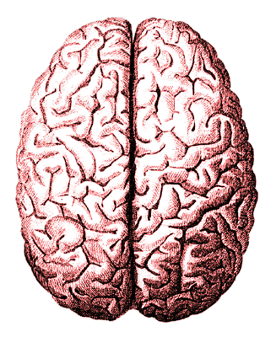

**Orange/Brain Surgery**

As a team, you will need to complete the following surgical steps and answer the questions about the parts of the brain and each parts function. When you are done, you will need to show me the finished product.

***Be sure to answer all of the questions in complete sentences*.**

Surgical Team:

**Checklist of items:**

**2-3 Paper Plates**

**1 Orange**

**1 Knife**

**1 Air Head**

**1 Pack of Lemon Heads**

**1 Pack of Gummy Worms**

**1 BlowPop**

**1 Laffy Taffy**

**1 Pack of Eggs**

**Plain Toothpicks**

**Colored Toothpicks:**

red or orange, yellow, green, blue

**Brain diagrams in your book on pages 67-85**

**Surgical Procedure:**

1. Carefully peel the skull from the brain. Do not puncture the white membrane, the meninges, that protect the brain and spinal cord.
2. You are now looking at the cerebral cortex. Describe the functions of the cerebral cortex. Why is it wrinkled? Why is the cerebral cortex so important?
3. Using the **plain toothpicks**, make two "eyes" with the **LEMON HEADS**. Be sure to put them on the "end" of the brain. How do the eyes see in relation to the hemisphere of the brain? You may need to consult your notes/book.
4. Using your knife carefully cut the corpus callosum without cutting your brain in half. Only cut down 1/2 inch (or until you see the white "thing" that runs down the center of the orange). This is the corpus callosum. Below, describe the job of the corpus callosum.
5. Using one **AIRHEAD** and one **LAFFY TAFFY** and one **EGG** attached together in that order with **toothpick(s)** (the natural colored ones), attach a brain stem in the lower portion. What behaviors does the brain stem monitor? What are the three parts of the brain stem?
6. Directly above the brain stem, attach the **BLOWPOP** for the CEREBELLUM. It should be on either side of the brain stem (use the stick to attach). What is the function of the Cerebellum?
7. Now, divide into lobes marking each with a **toothpick**. Do this on both hemispheres. Below describe the function of each:

* Frontal Lobe: Red/Orange
* Parietal Lobe: Yellow
* Occipital Lobe: Green
* Temporal Lobe: Blue

1. Use two different colored **GUMMY WORMS** to indicate the motor cortex located at the rear of the frontal lobe and the sensory cortex located at the front of the parietal lobe. What are the functions of these two structures? How do they differ?
2. Using the original cut of the corpus callosum, ON THE RIGHT SIDE, cut a perpendicular line into the brain, removing a section of the right hemisphere. What specialized functions is the right hemisphere responsible for?
3. Cut off a **GUMMY WORM** in half. This is the hypothalamus. Place it inside your incision. What are the functions of the hypothalamus?
4. Now, use a whole **GUMMY WORM** of a different color. This is the thalamus. Place this on top of the hypothalamus. What is its function?
5. Locate Wernicke's area in the left hemisphere. Break a natural colored toothpick in half and use an **EGG** at the end of the toothpick to mark its location. What is the function of Wernicke's area?
6. Locate Broca's area in the left hemisphere. Use the other half of the toothpick to mark its location with a **LEMON HEAD**. What is the function of Broca's area?
7. Describe the specialized functions of the left hemisphere of the brain.
8. **Extra Challenge**: Amygdala and hippocampus—decide on a piece of candy to represent them accurately. Describe the function and location of both.
9. Once you have completed your surgery, I will need to offer my professional opinion on the results. Please notify me when you are ready for my consultation. Upon my approval, you may snack on any part of the brain you wish!

**YOU MAY NOW EAT YOUR BRAINS.**

**PLEASE CLEAN UP YOUR SURGICAL AREA!**